EXPERIMENT 2
EXPLORATORY DATA ANALYSIS (EDA) – DATA IMPORT AND EXPORT

AIM:
To import data from various sources such as CSV, Excel, SQL, and Web, perform basic inspection using Pandas, and export the processed data into different file formats.

ALGORITHM 1 :

- Import Pandas library
- Load CSV file using read_csv()
- Display first few records
- Check data structure
- Analyze imported data

PROGRAM 1 :
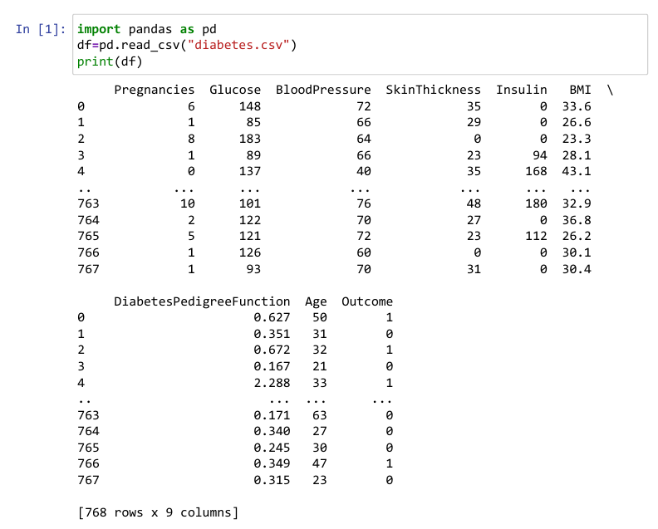

PROGRAM 2 :

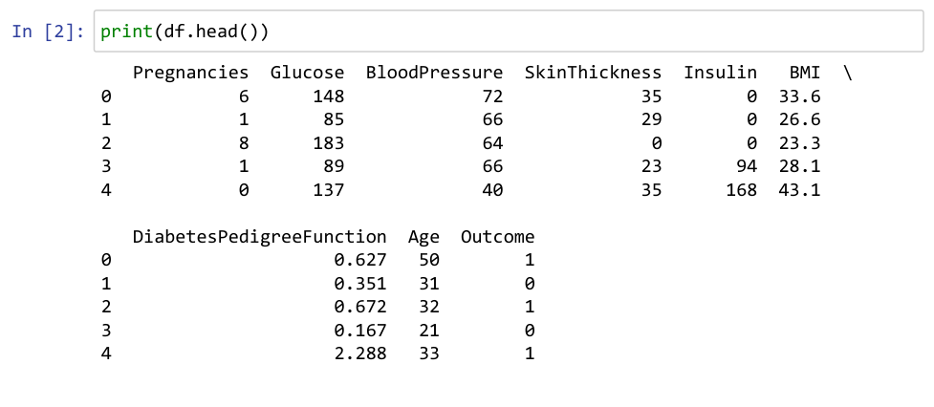
PROGRAM 3:

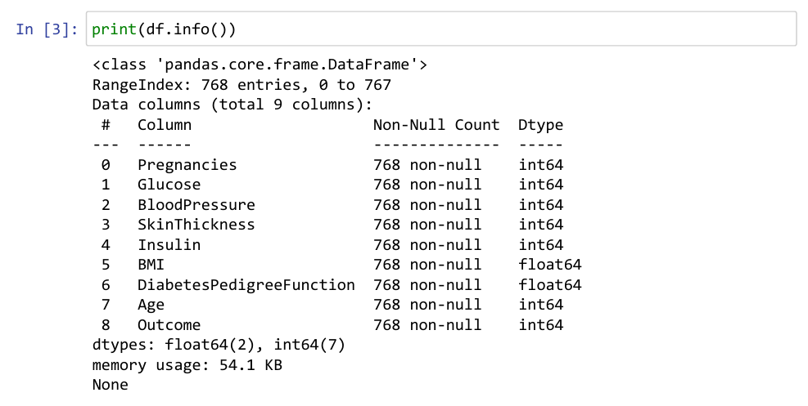
PROGRAM 4:

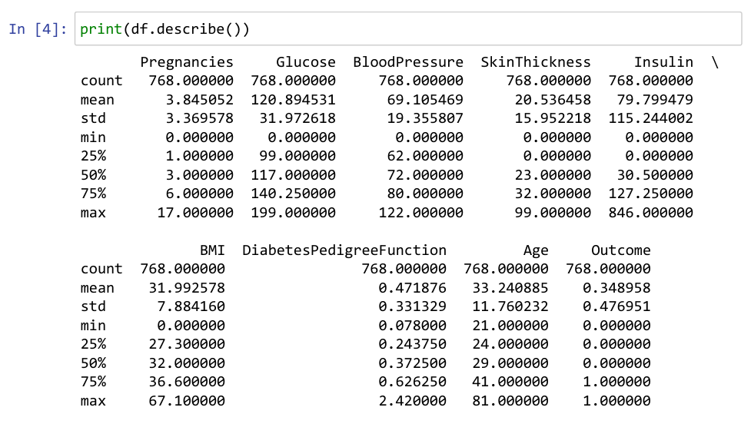
ALGORITHM 2:

Importing Excel File Step 1
- Create Excel file
- Use read_excel()
- Display records
- Verify imported data

PROGRAM 5:
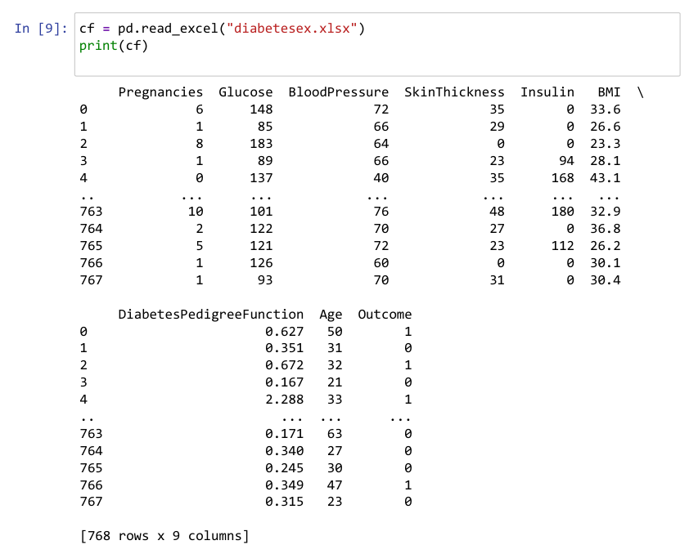

ALGORITHM 3 :

Importing SQL Data
- Create SQLite Database
- Insert records
- Retrieve records using SQL Query

PROGRAM 6:
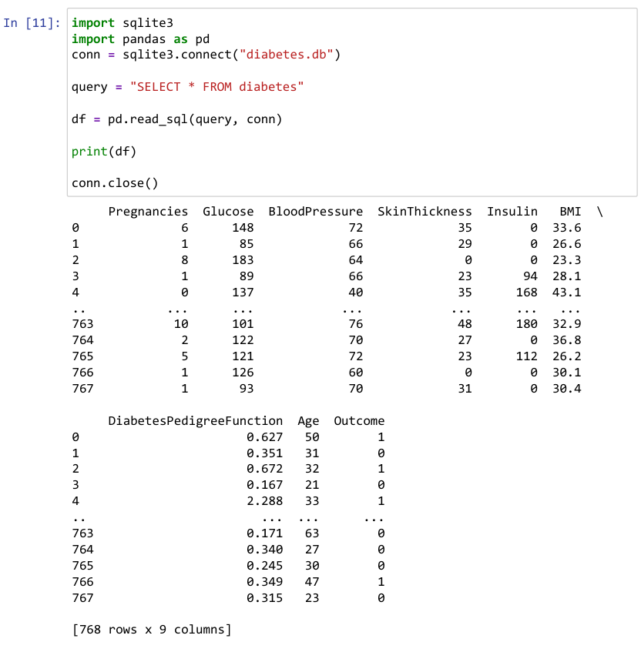

ALGORITHM 4:

Data from Web
- Specify URL
- Load data using read_csv()
- Display imported records

PROGRAM 7:
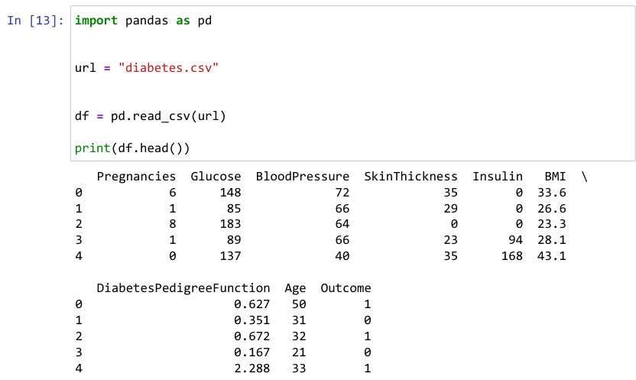
PROGRAM 8:
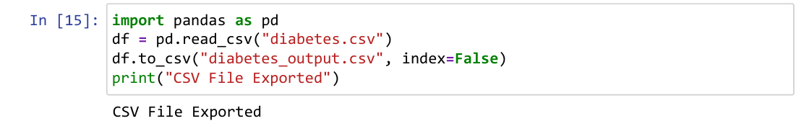
PROGRAM 9:
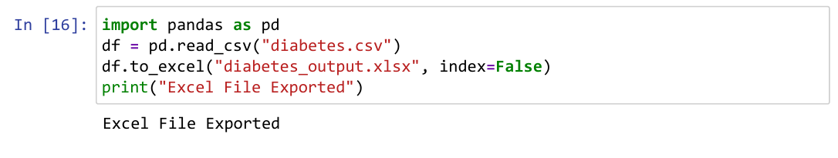
PROGRAM 10:
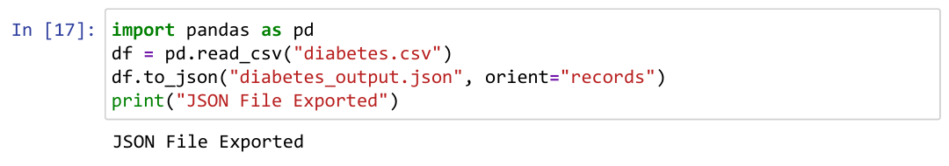
PROGRAM 11:
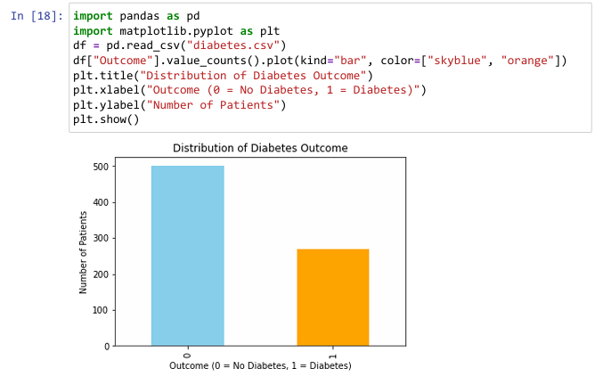

Result:
Successfully imported data from various sources such as CSV, Excel, SQL, and Web, and performed basic inspection using Pandas, and exported the processed data into different file formats.

